

American International University- Bangladesh

CSC 3222: Web Technologies

CO1.1 and CO2.1 Evaluation

Project Report

Spring 20-21

Project Title: Alumni Management System

Section: I

|  |  |
| --- | --- |
| Student Name | Student Id |

Introduction:

This project is very useful for the students as well as the faculty members and alumni members. A student can get the opportunity to find a job or scholarship quickly. Faculty members and Alumni members can help a student to get a job or scholarship. This is why we chose this project.

Background Study

In this project an user can login to the system and register in the system. They can upload pictures, view their profile, can add members, add post, delete post and create community.

We have taken help form websites such as W3schools, Youtube, Tutorials point etc.

Requirement Analysis:

1.User Category:

There are 5-types of Users here. They are:

* Student
* Faculty
* Alumni (Ex-Student)
* System Admin
* Community Admin

1. Feature List:

* In this project the “Student” has the following features:
* Can add post
* Can edit post information
* Login
* Registration
* Reset password
* Upload picture

In this project the “Faculty” has the following features:

* Can add post
* Can edit post information
* Login
* Registration
* Reset password
* Upload picture

In this project the “Alumni” has the following features:

* Can add post
* Can edit post information
* Login
* Registration
* Reset password
* Upload picture

In this project the “Community Admin” has the following features:

1.Can create Community

1. Delete post
2. Block member

In this project the “System Admin” has the following features:

1. Can add member

2. Can verify Student/Faculty profiles -- Can block Student/Faculty

3. Can manipulate information (edit-delete-view etc.) etc…

Design:

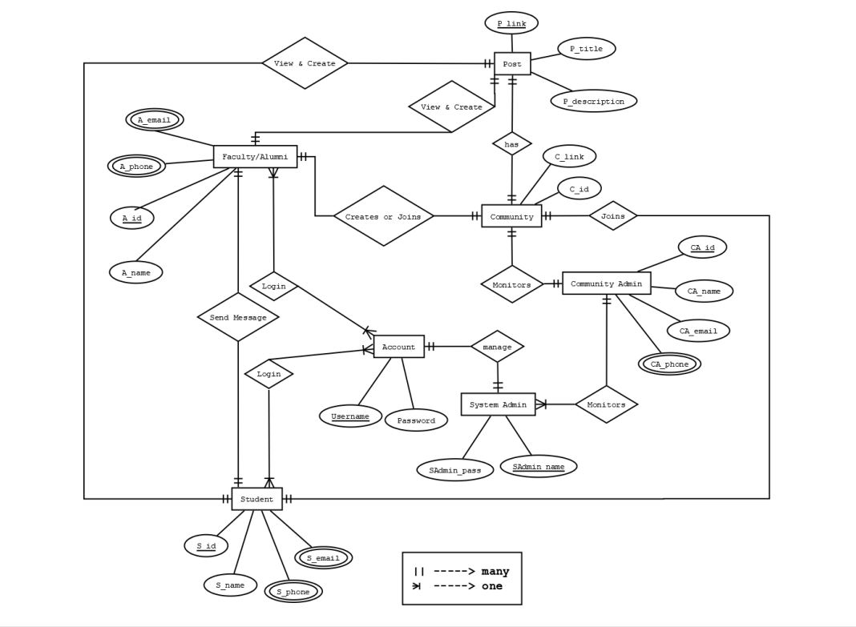

Tools Used:

To develop this project, we have used the following:

• Sublime text

• Visual Studio Code

• Canva

System Images against the Specification:

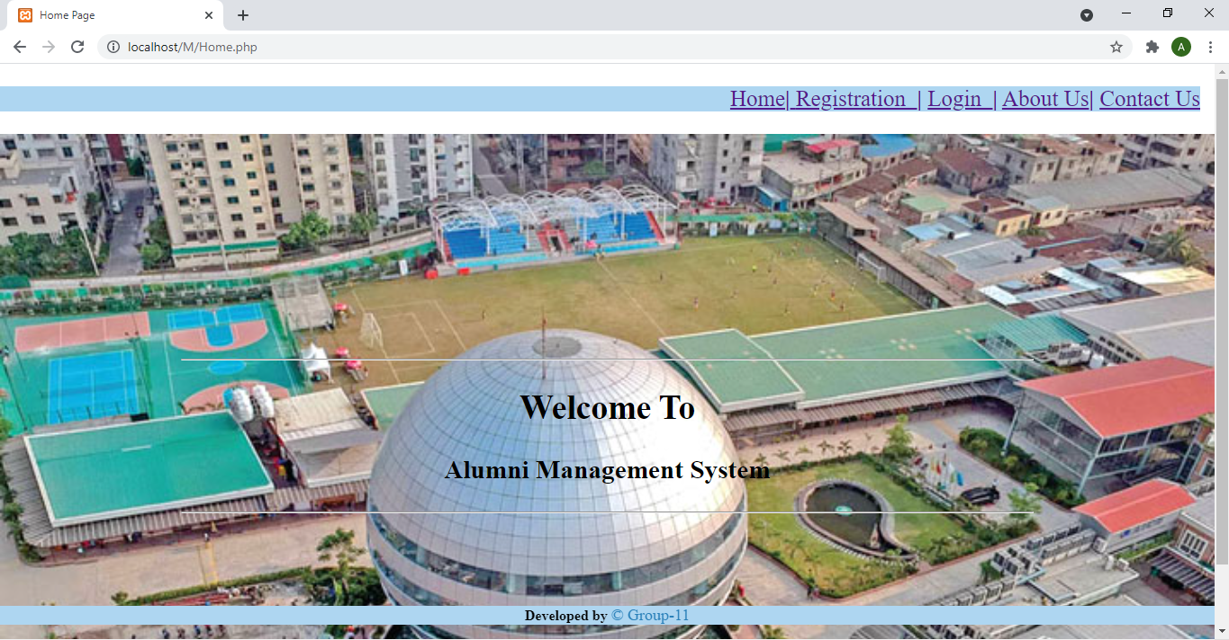

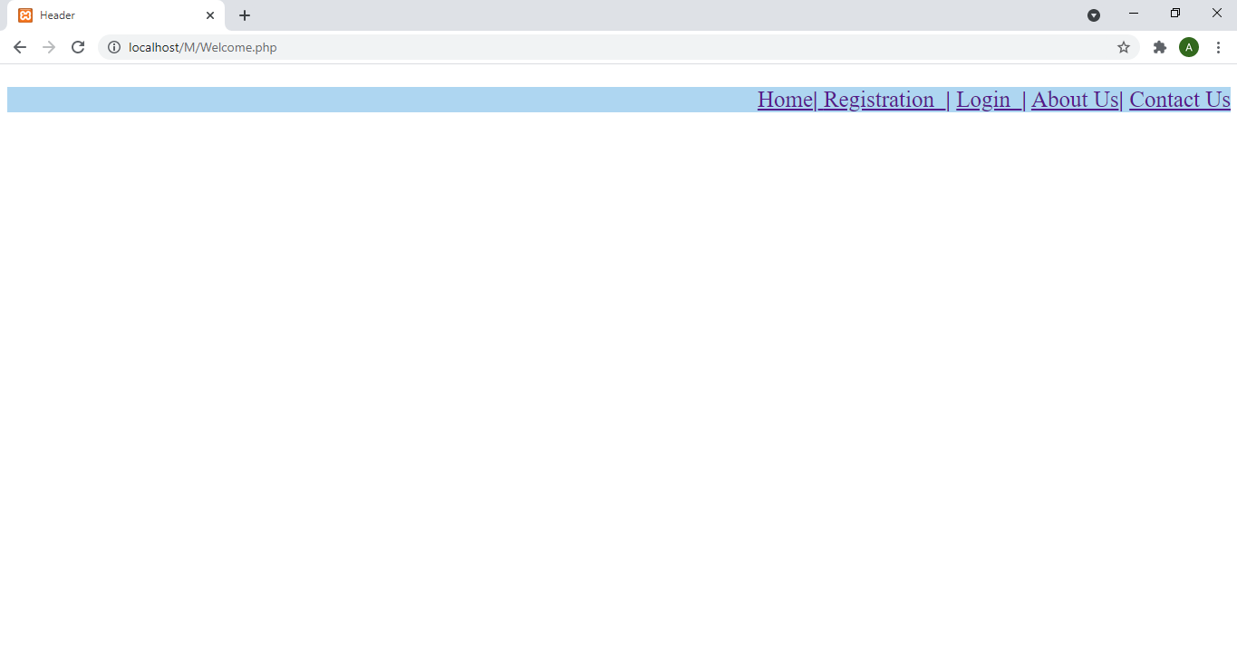

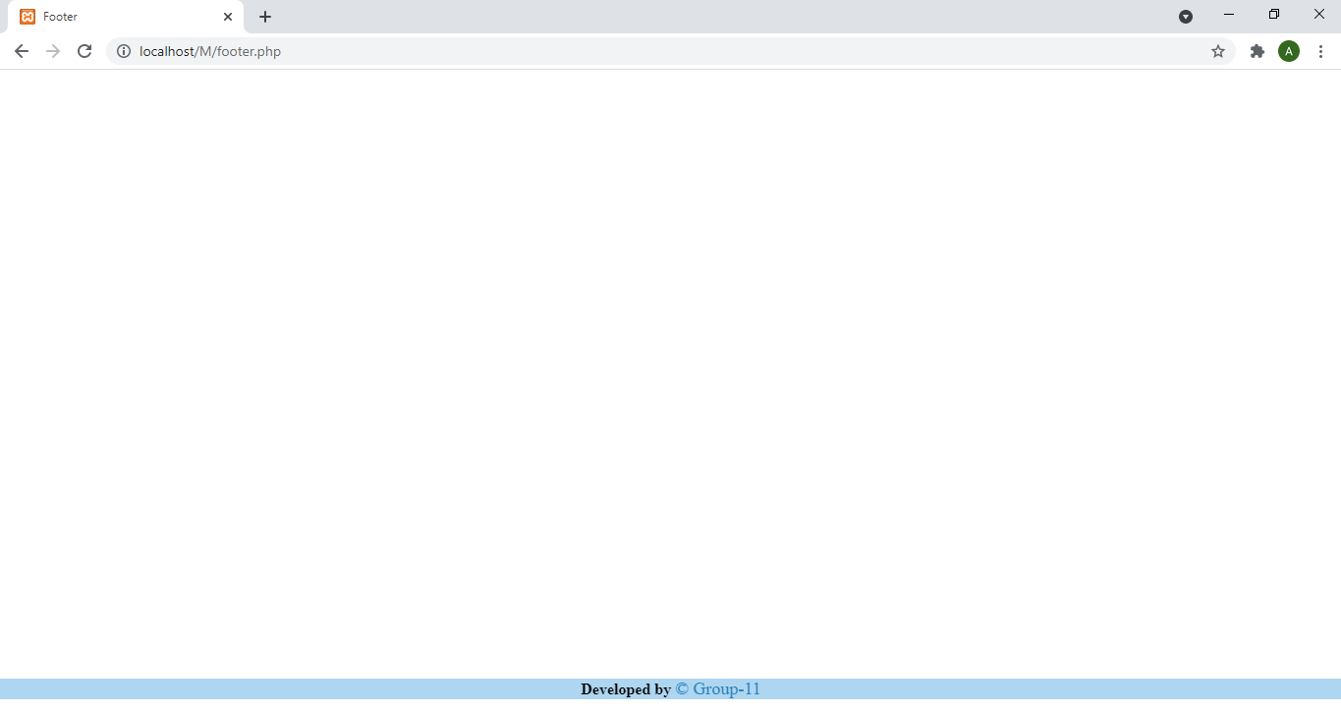

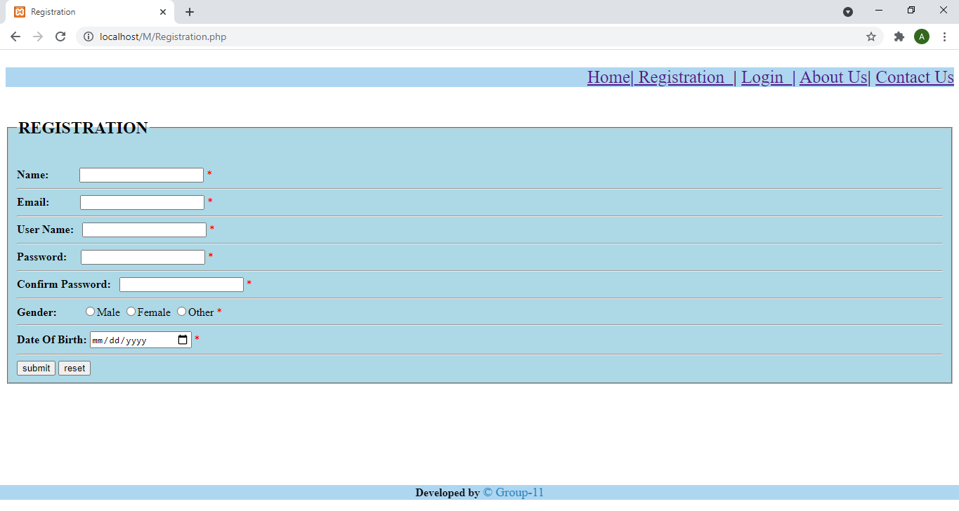

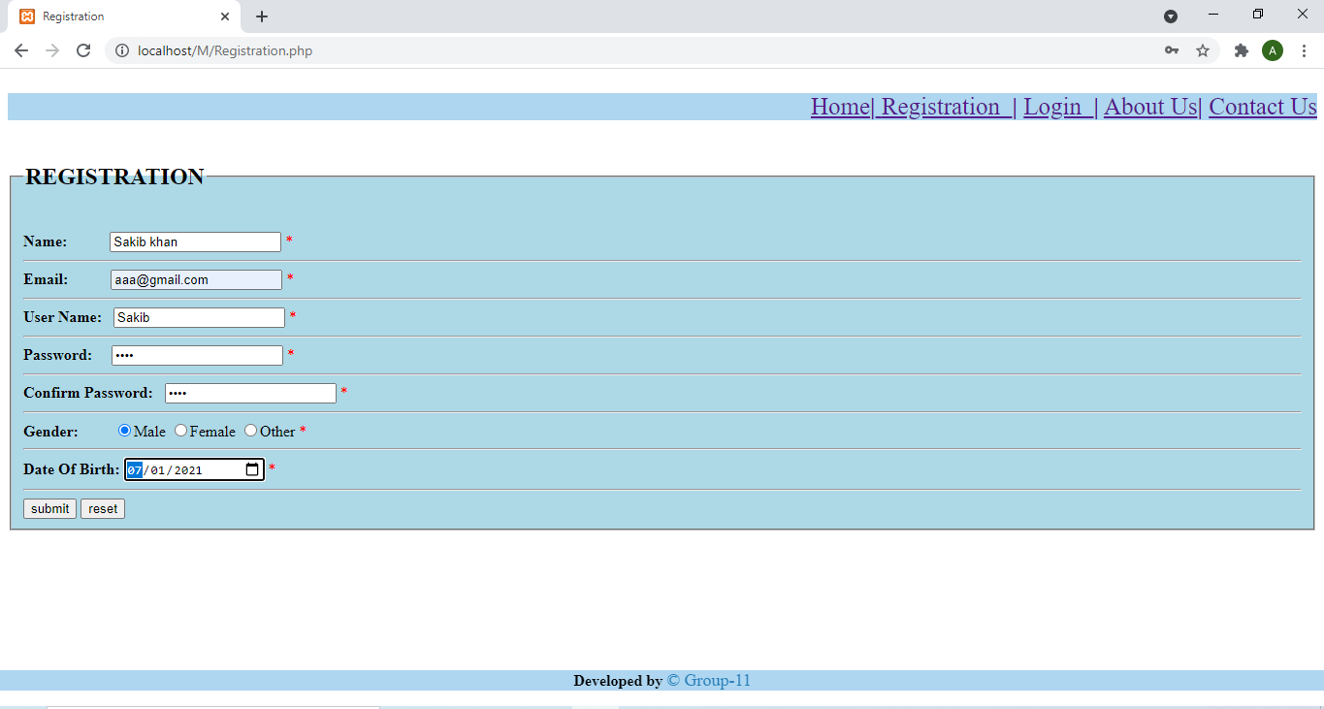

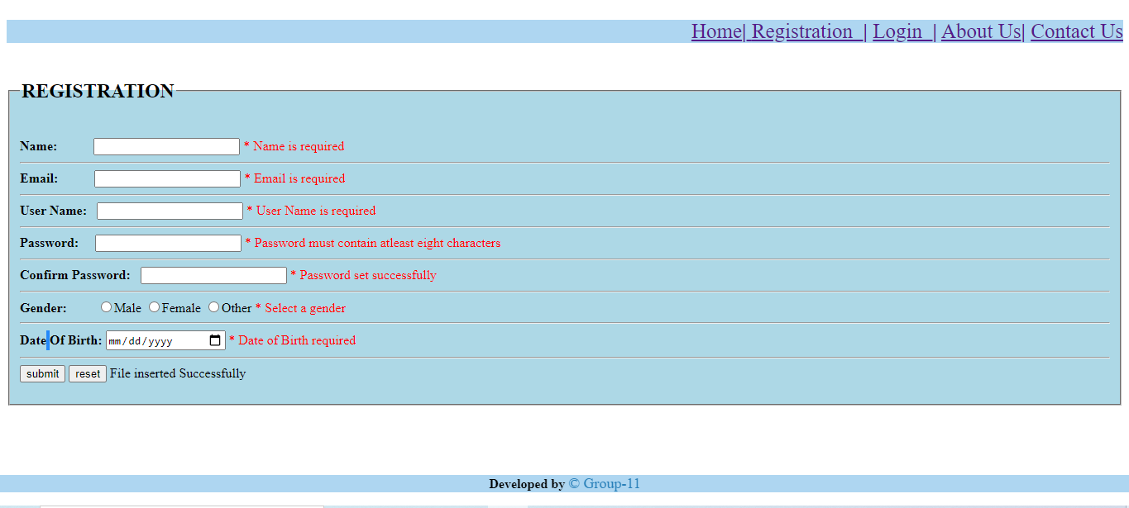

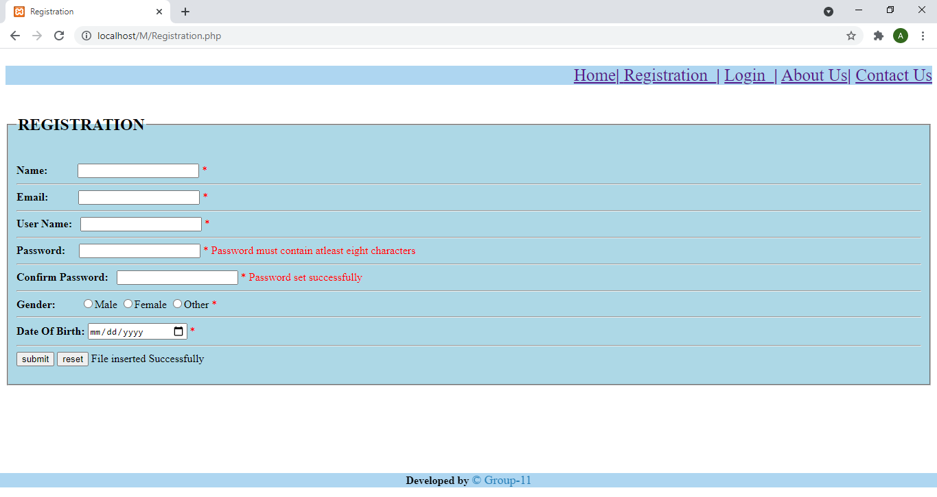

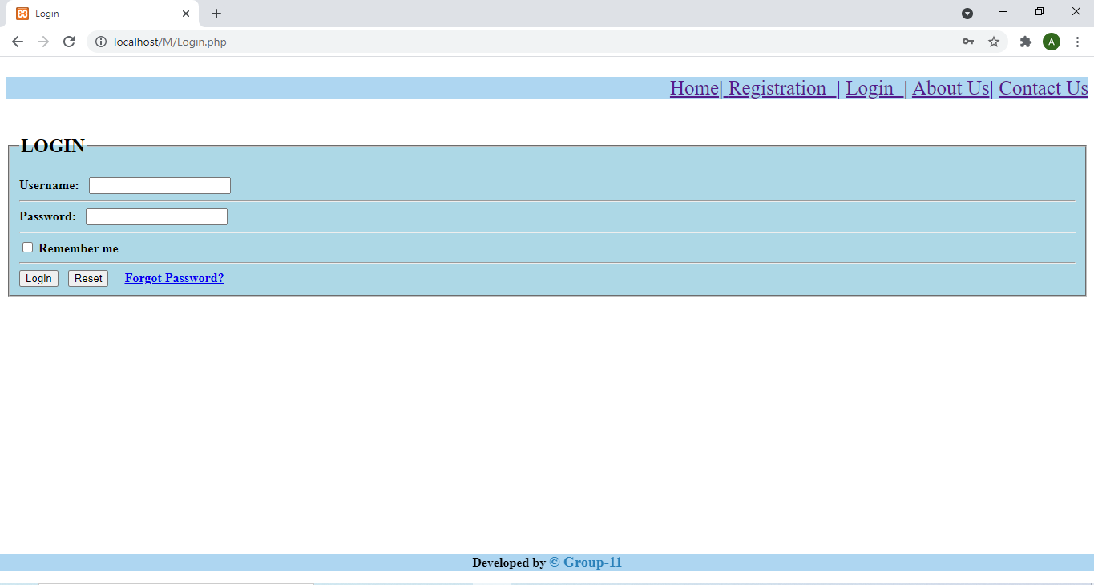

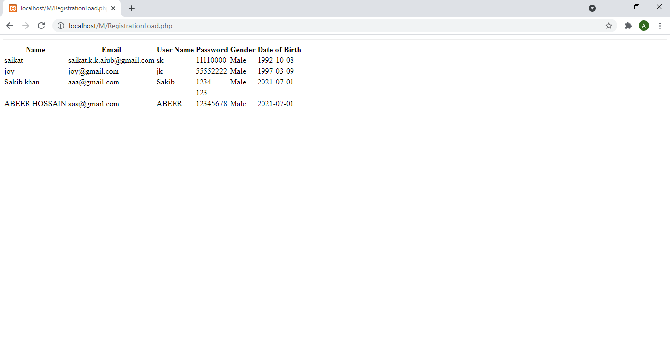

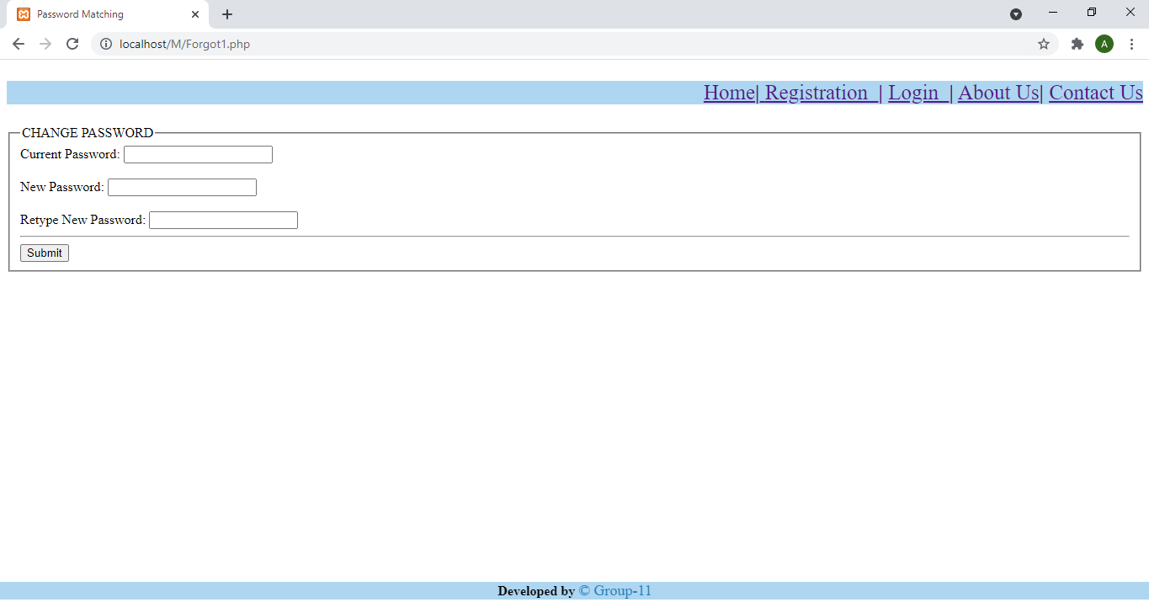

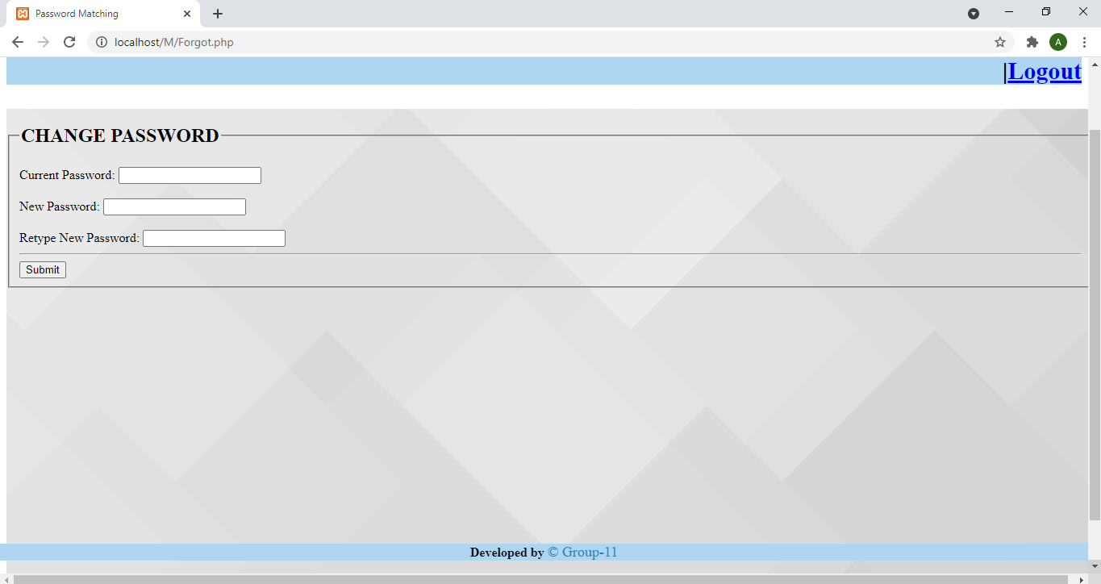

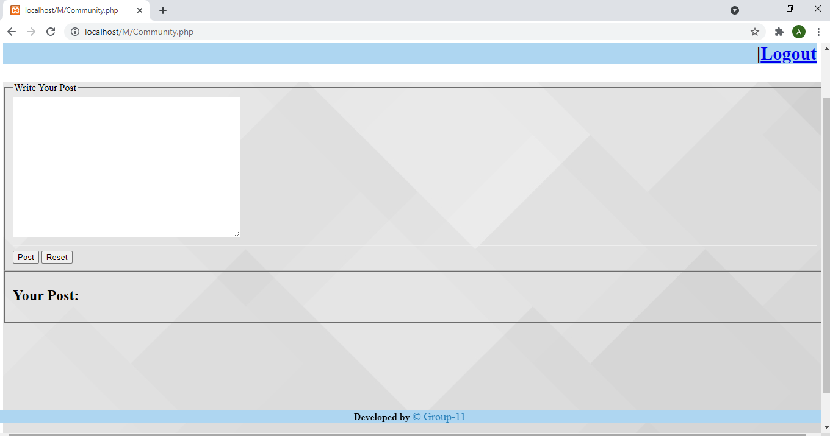

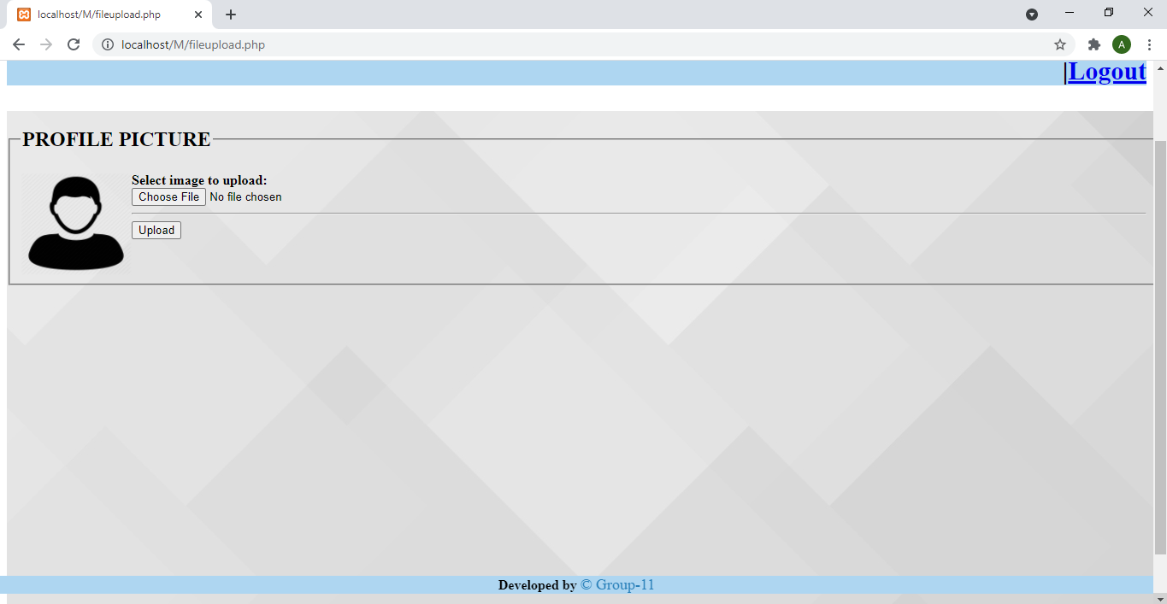

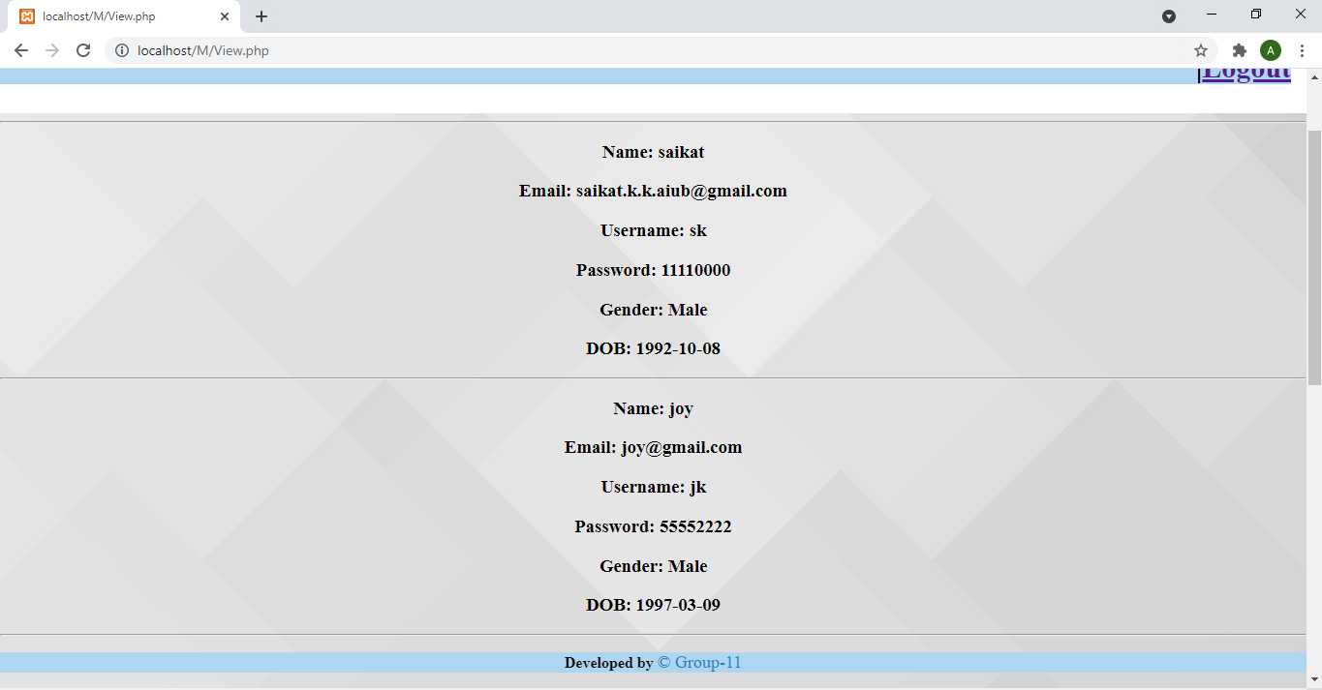

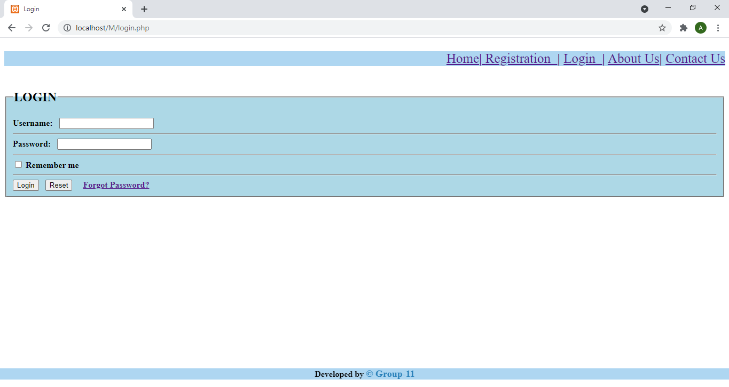

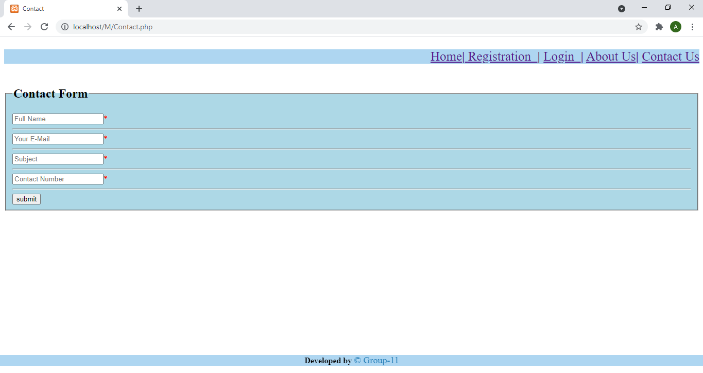

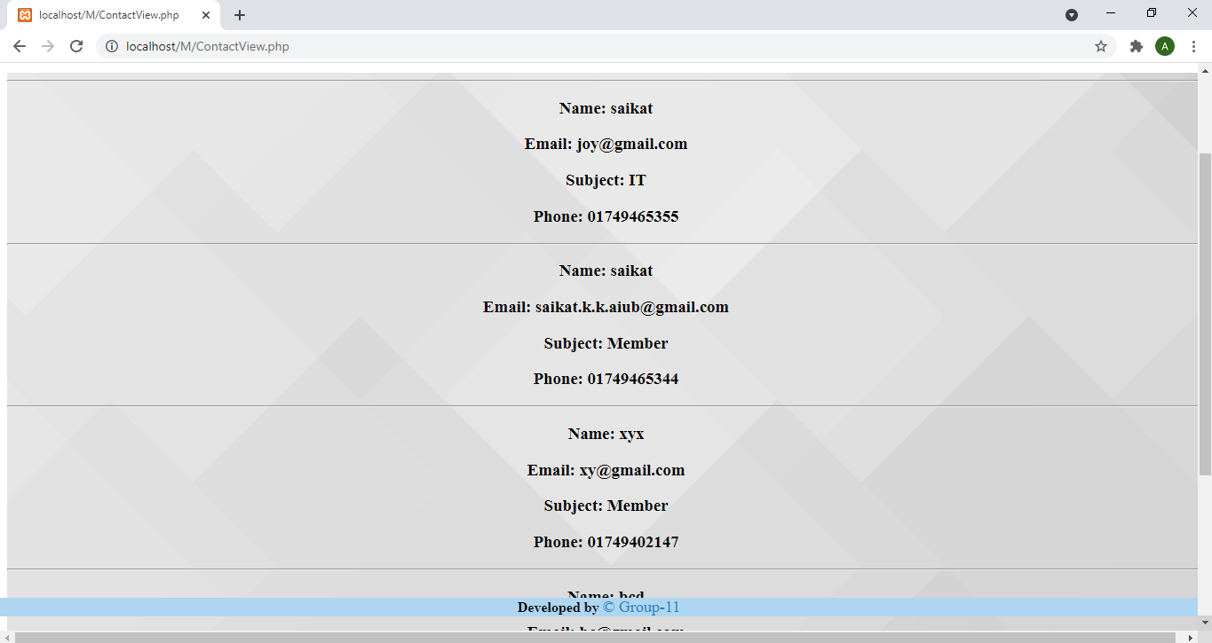

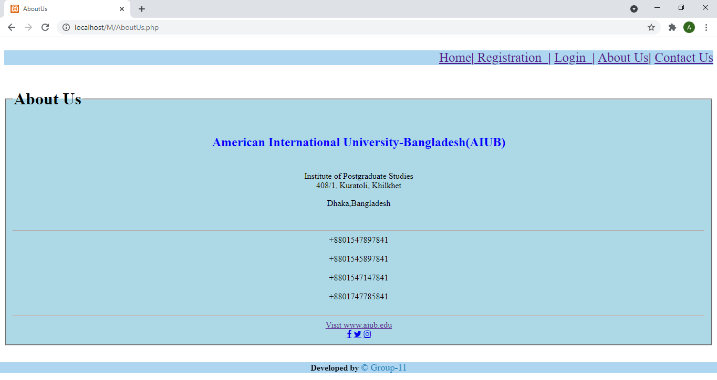

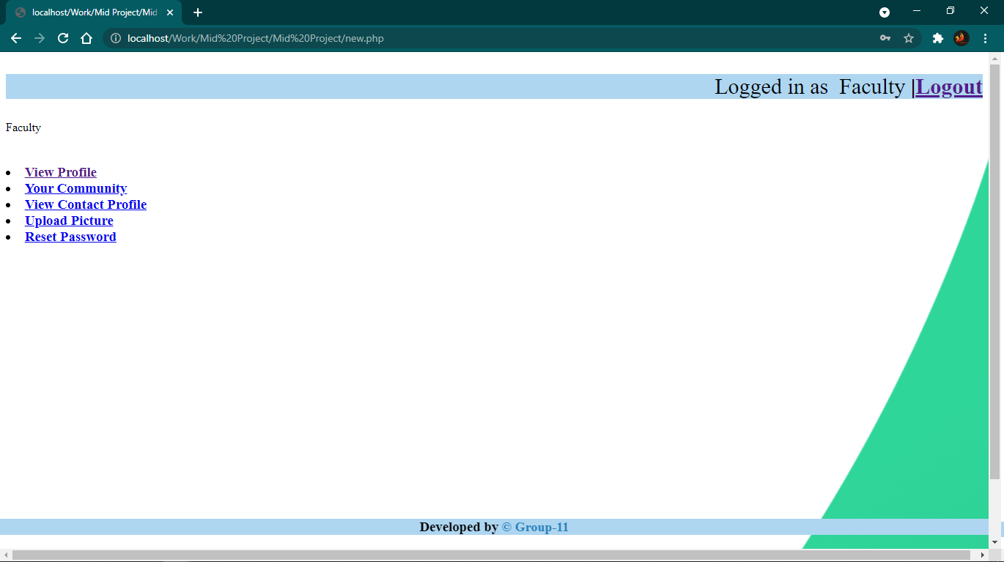

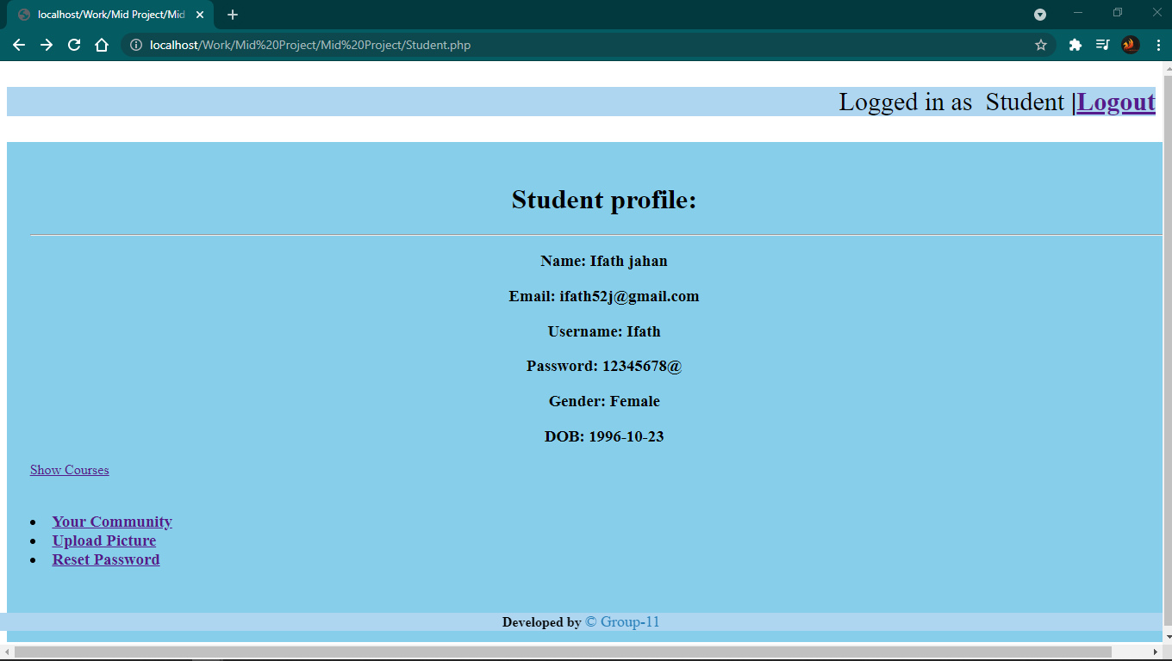

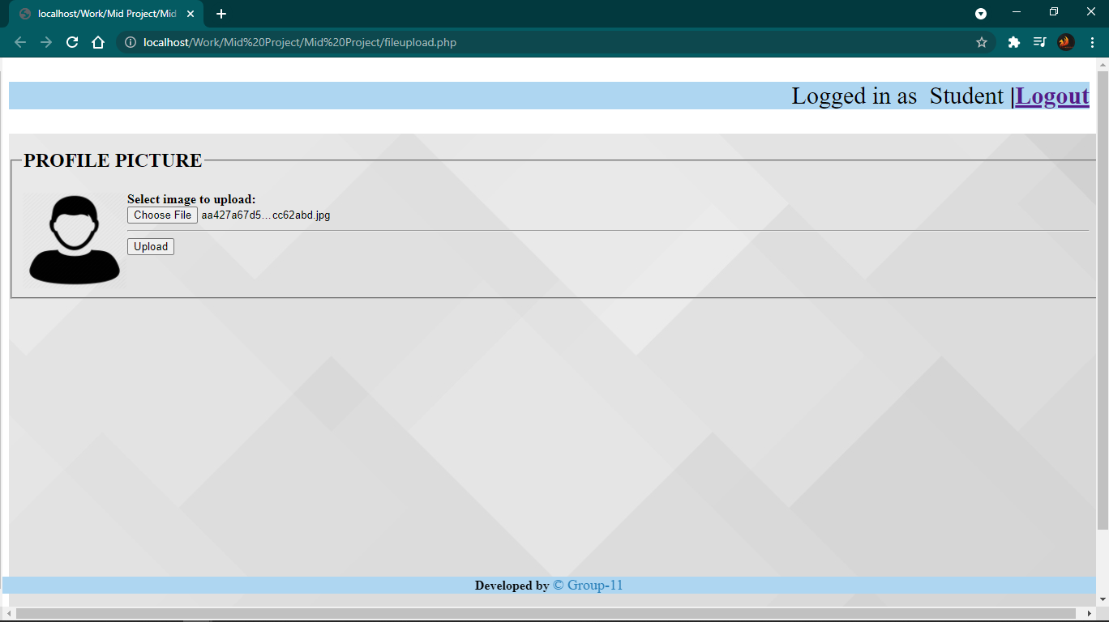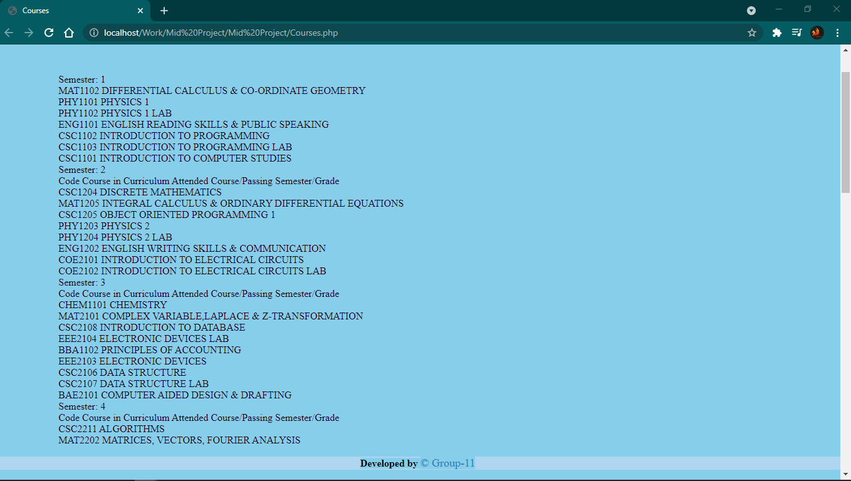

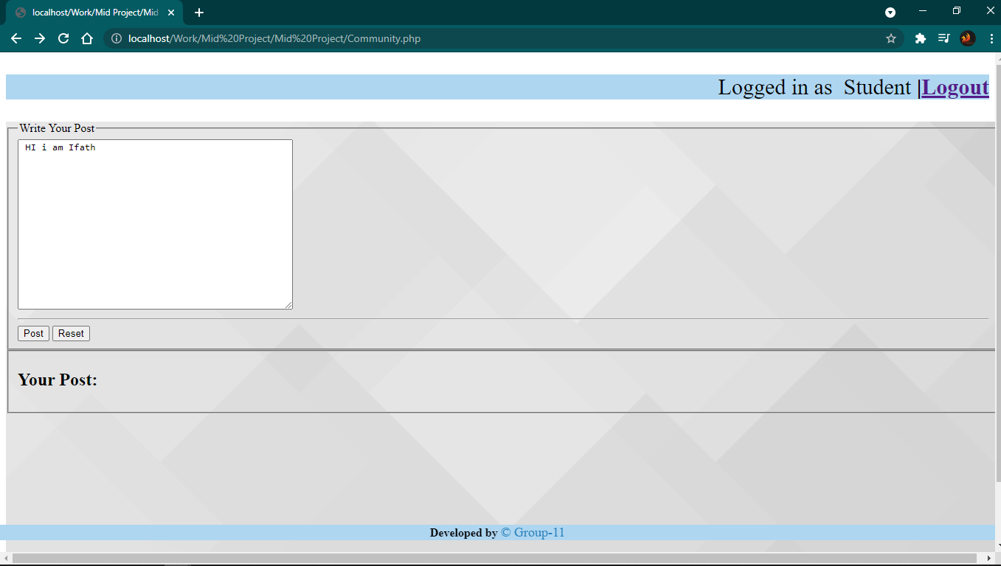

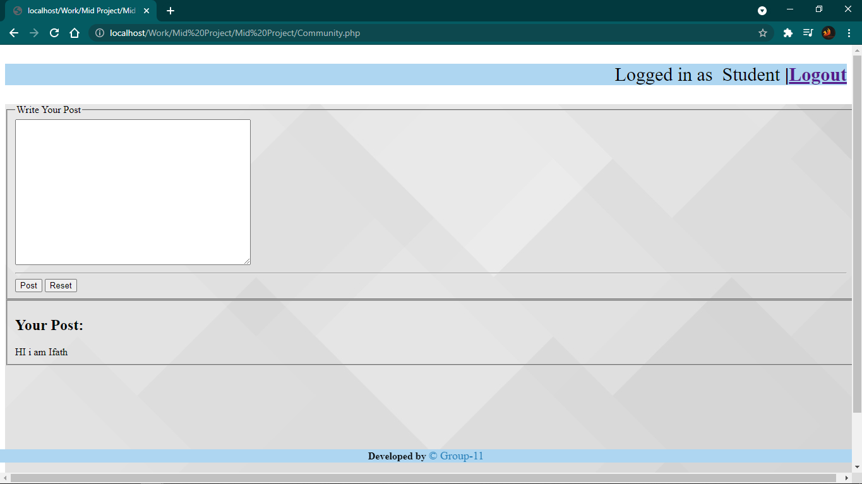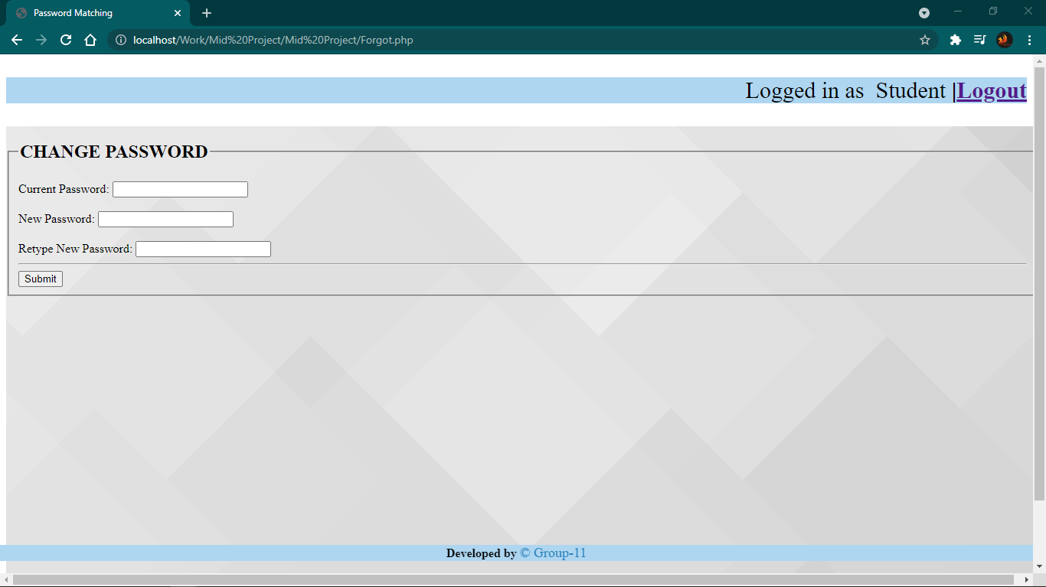

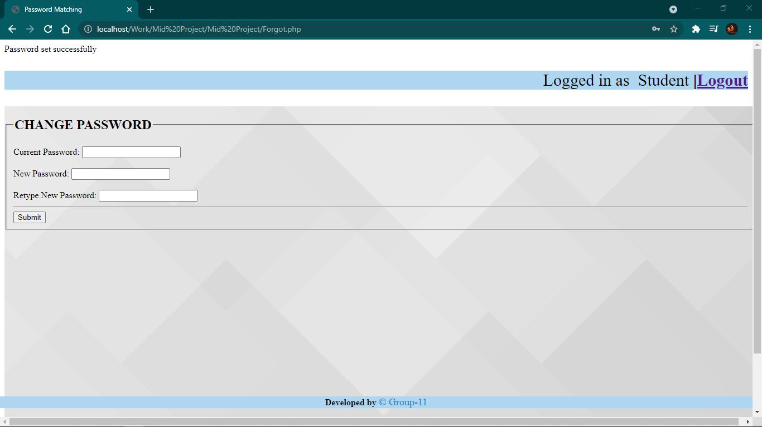

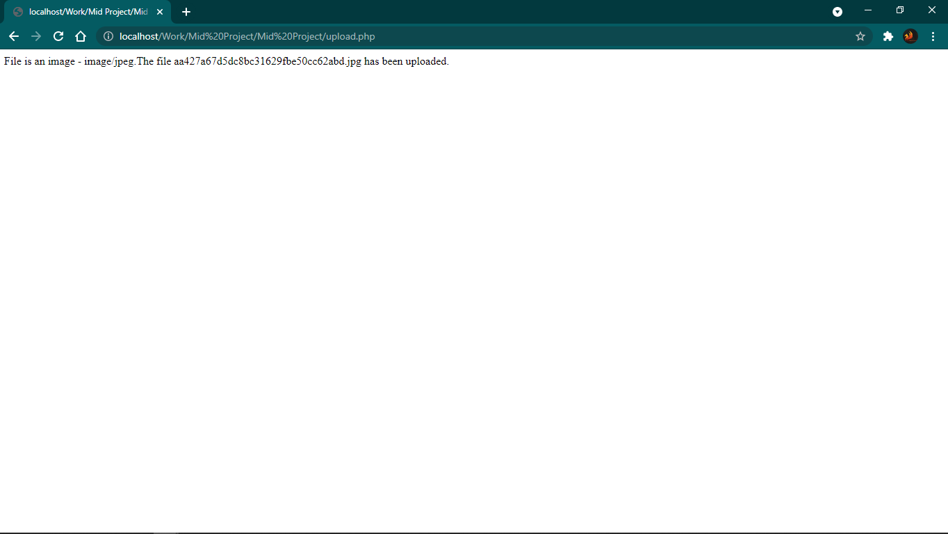

Impact of this Project:

Nowadays it is very difficult to find a job or to get a job and scholarship, specially for the fresh graduate or undergraduate students. By using this project a student can find job and scholarship very easily. Alumni members can post job ads if their company is hiring someone, can post scholarship offers. If a student is eligible for the job or scholarship he/she can apply for that. Students can get connected with their faculty members and their seniors. So, it is very helpful for them.

Limitations and Possible Future Improvements:

In this project we can’t ensure that the students can get their desired job or scholarship by using this project. We will try to improve this limitation in future.

*[Note: Make sure that your report is maximum 10 pages (including cover page). Print (Colored) the report and submit it with spiral bind.]*

|  |  |  |  |  |  |
| --- | --- | --- | --- | --- | --- |
| CO1.1 and CO2.1 Evaluation: Project Report Evaluation | | | | | |
| Project Proposal  (5) | Background  Study  (5) | Requirement Analysis  (5) | Entity  Diagram  (5) | System Images  against the  Specification (5) | Total (25) |
|  |  |  |  |  |  |
|  | | | | | |